Philadelphia University  Lecturer: Mr. Abdalrahman Obidat  Coordinator: Mr. Abdalrahman Obidat  Internal Examiner: Dr. Mohammad Taye |  | Faculty of IT  Department of SE  Examination Paper  KEY

Computer Aided Software Engineering (721445+722489) Section 1 Second Exam

Time: 1 hour

Student Name: Student #:

Information for Candidates
- This examination paper contains 5 questions on 2 pages totaling (20) marks.
- The marks of questions are shown in round brackets. (-- marks).
Advice to Candidates
1- You should attempt all questions.
2- You should write your answers clearly.

I. Basic Notions
Objectives: The aim of the questions in this part is to evaluate the required minimal student knowledge and skills. Answers in the pass category represent the minimum acceptable standard.

Question 1: Give three examples for each of the following: (4.5 marks)
A) Potential CASE tool costs.
- Initial training and education.

- Evaluation costs.

- Maintenance of the model over time.

- Upgrade costs of the tool.

- Time lost waiting for the tool to do its job

B) Workbenches classes.
- Business planning and modeling
- Analysis and design
- User-interface development
- Programming
- Verification and validation
- Maintenance and reverse engineering
- Configuration management
- Project management

II. Familiar Problems Solving
Objectives: The aim of the questions in this part is to evaluate that have some basic knowledge of the key aspects of the lecture material and can attempt to solve familiar problems.

Question 2: Visio Case tool can help users to create the following: (4.5 marks)
A) Cross-functional Flowcharts. What is the difference between this kind of flowchart and the usual flowchart?
Can use cross-functional flowcharts to understand how processes work and which departments are involved.
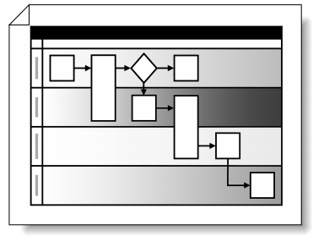

B) Brainstorming Diagrams. How can Project managers use brainstorming diagrams in team meetings?
Project managers can use brainstorming diagrams in team meetings to analyze and solve process problems or identify new product ideas.

Question 3: In Leap SE Case tool: (4.5 marks)
A) There are three categories for requirement, what are these categories?
Functional requirements
Structural requirements
Technical requirements

B) It provides a way to “leap over” a substantial part of the Systems Engineering (SE) effort so critical to the execution of any software development project. How?

By translating the written word into a cohesive set of classes, attributes, methods, relationships, and inheritance hierarchies, Leap SE enables software development to get a much-needed head start on design and implementation

C) Fill the following requirement using the Association template in fig1
"The system shall provide the capability to assess the weight of foreign cargo using the import calibration of the runway freight scale when the transit status of the foreign cargo is updated from in flight to on premises." (4.5 marks)
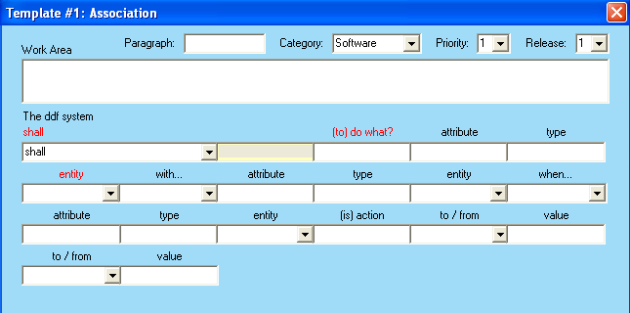
Fig 1
SOL:
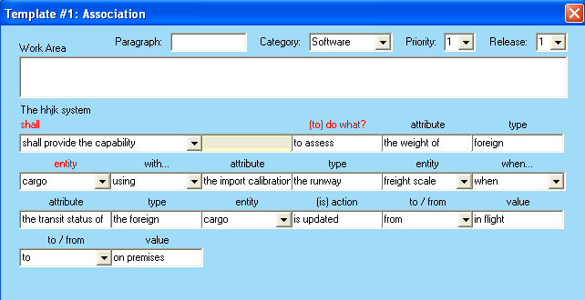

Question 4: Common CASE risks and associated controls include: (3 marks)
A) Inadequate standardization
Linking CASE tools from different vendors may be difficult if the products do not use standardized code structures and data classifications.

B) Unrealistic expectations
Implementing CASE strategies usually involves high start-up costs. Generally, management must be willing to accept a long-term payback period.

C) Weak repository controls
Failure to adequately control access to CASE repositories may result in security breaches or damage to the work documents, system designs, or code modules stored in the repository

Explain each of the above risks.

III. Unfamiliar Problems Solving
Objectives: The aim of the questions in this part is to evaluate that you can make progress towards the solution of unfamiliar problems, and can set out reasoning and explanation in a clear and coherent manner.

Question 5: CASE environments are classified based on the focus/basis of integration to Five different categories: Toolkits, Language-centered, Integrated, Fourth generation and Process-centered environment. Discuses these categories in order to conclude short summery about them. (4 marks)

Toolkits:
Typically, the support provided by a toolkit is limited to programming, configuration management and project management. However, since the only constraint for adding a new component is the formats of the files, toolkits can be easily and incrementally extended

Language-centered:
The environment itself is written in the programming language for which it was developed, thus enabling users to reuse customize and extend the environment.
Integration of code in different languages is a major issue

Integrated:
These environments achieve presentation integration by providing uniform, consistent, and coherent tool and workbench interfaces. Data integration is achieved through the repository concept

Fourth-generation:
In general, they include programming tools, simple configuration management tools, document handling facilities and, sometimes, a code generator to produce code in lower level languages. Informix 4GL, and Focus fall into this category.

Process-centered:
A process-centered environment operates by interpreting a process model created by specialized tools. They usually consist of tools handling two functions:
  - Process-model execution
  - Process-model production

